**SOP FOR**

1. **PURPOSE: Safe maintenance of Tap hole drill machine for optimum**

**Performance .**

1. **SCOPE:** **Blast Furnace Accessories .**
2. **RESPONSIBILITY: Engineer In charge and workmen on job .**
3. **PROCEDURE: MAINTENANCE OF TAP HOLE DRILL MACHINE.**

PPE –s to be used :

* Helmet, Safety shoes, Cotton cloth and complete sealed goggle
* Work No 1 : Drill machine drifter changing
* Work No 2 : Replacement of hoses
* Work No 3 : Replacement of swiveling cylinder
* Work No 4 : Replacement of chain
* Work No 5 : Replacement of hooking cylinder
* Work No 6 : Replacement of shank shaft.
* Work No 7 : Removal of drill rod / shank adaptor incase of jamming.
* Work No 8 : Replacement of face plate.
* Work No 9 : Lubrication of Drill machine.
* Work No 10 : Drill machine assly replacement

Aspect – impact

|  |  |
| --- | --- |
| Oil Spillage | Land contamination & Resource Depletion |
| Scrap generation | Resource Depletion |
| Oil traced waste generation | Land contamination & Resource Depletion |

Hazards identified

Mechanical hazard

1. Trapping in between moving parts
2. Impact of hammer, drill machine, etc
3. Fall of objects such as hammer, bolts, steel items
4. Injection of metal parts
5. Splashing of oil during hydraulic hose changing.

Physical hazard

1. Burn injury due to hot metal splashing
2. Burn injury due to slip in launder / runner
3. Gas poisoning from furnace and tap hole.
4. Fall hazard due to oil spillage

**Behavioral Hazards:**

1. working without all required PPE’s
2. Working under influence of alcohol
3. Horse play
4. Casual approach
5. Not following SOP/WI while carrying out the job

Work No 1 :Drill machine drifter changing

1. Inform BF#3 control room incharge, SS and cast house in charge & take work permit .
2. Take electrical shutdown of power pack motors..
3. Isolate all hydraulic line valves & put mechanical LOTO for hydraulic valves of drill machine .
4. Remove the external cover of the drifter assembly.
5. Remove all hose connection on the tap hole side of drill machine & ensure to collect the drained oil in a bucket /tray.
6. Remove the drill machine drifter assembly by removing the mounting bolts.
7. Fit the spare drifter assembly and tighten the mounting bolts.
8. Connect all the hoses and ensure that the O rings are in good condition before tightening the hoses.
9. Remove isolation LOTO & Open the hydraulic line valves.
10. Clear the electrical shutdown of the power pack motors
11. By standing away from the drill machine , request operator to take trial of drill machine and check for any oil leakage
12. Fix back the cover
13. Clear the work permit.
14. Hand over it to operation.

Work No 2 : Replacement of hydraulic hoses .

1. Inform Control room incharge, SS and cast house in charge & take work permit.
2. For changing the hoses ensure that drill machine assembly is located at extreme back position.
3. Ensure that operator has switched off the pumps .
4. Remove the field key located besides Mudgun & Drill machine .
5. Close the shut off valves of the hydraulic lines of the hoses to be replaced & put isolation LOTO for hydraulic valves.
6. Slowly loosen the hose fittings to release the hydraulic oil pressure and collect the oil in empty container/tray. Care should be taken to prevent the oil from spilling. Follow procedure [WI/MAINT/93](http://sgl-panj-sp-01:8080/sil_quality/Mech.html/Activity%20WI/WIMAINT93%20LUBRICATION.htm) .
7. Replace the damaged hoses with new ones. Replace the dowty/copper seal if required.
8. Hoses are to be fitted without twisting and entanglement.
9. Fix back the field key
10. Remove isolation LOTO & open the shut off valves of the hydraulic lines of the hoses replaced.
11. Take the trial of the drill machine check the leakages if any.
12. Ensure house keeping
13. Give clearance to the production by clearing the work permit.

Work No 3: Replacement of swiveling cylinder

1. Take clearance from production cast house engineer by taking work permit
2. Swivel the machine and keep it perpendicular to main runner.
3. Take shutdown of pumps.
4. Close the shut off valves of the swiveling cylinder & put LOTO.
5. Disconnect the hose and collect the oil in bucket .Follow [WI/MAINT/93](http://sgl-panj-sp-01:8080/sil_quality/Mech.html/Activity%20WI/WIMAINT93%20LUBRICATION.htm) .
6. Dismantle the old cylinder and fit spare cylinder.
7. Connect the hoses and ensure to check O rings for any damage before tightening.
8. Remove isolation LOTO & Open the shut off valves of the swiveling cylinder.
9. Clear the electrical shutdown.
10. Take swiveling trial of drilling machine, by standing away from the swing area of drilling machine and check for any hydraulic leakage.
11. Check drilling machine with respect to tap hole centre, adjust if needed , by adjusting the swiveling cylinder fork threads. Ensure that gap between fork and cylinder piston rod edge is not more than 15mm , else cylinder will get disconnected from fork.
12. Give clearance to production department after clearing the work permit.

**Work No 4 :Replacement of carriage chain.**

1. Take clearance from Production department. by taking work permit.
2. Remove the field key located adjacent to the mudgun Dismantle the hydraulic drifter as per Work no.1 and steps A to D
3. Close the swiveling line valves near the DC valve of mudgun & drill machine & put LOTO.
4. Identify the master link and disconnect the same.
5. Confirm if number of links of new chain is as per requirement.
6. Connect the new chain to one end of old chain.
7. Now slowly operate the carriage feed motor in such a manner that old chain shall get disengaged from the machine and new chain gets engaged on the machine.
8. While engaging new chain onto the machine , ensure the new chain is laid free , with no obstacles .
9. Once entire chain is rolled on to the machine, disconnect the old chain from the new chain .
10. Now join the 2 ends of the new chain with master link and adjust the chain tension by adjusting the chain tensioner bolt.
11. Fix back the drifter assembly .

Remove isolation LOTO & Open the valves

1. Fix back the field key & take trial
2. Clear the work permit and give clearance

**Work No 5 :Replacement of hooking cylinder.**

1. Take clearance from Production engineer by taking work permit.
2. Close hydraulic valves & put isolation LOTO
3. Lower the drill machine boom by operating the hooking cylinder .
4. Take electrical shutdown of pumps.
5. Close the shut off valves of hooking cylinder
6. Remove the hoses and collect the oil in the barrel.
7. Remove the mounting pins of the cylinder.
8. Dismantle the old cylinder & fit spare cylinder.
9. Ensure pins are locked with locking plates.
10. Connect the hoses and clear the electrical shutdown , later take trial2-3 times.
11. Remove isolation LOTO & open the shut off valves of hooking cylinder
12. Give clearance to Production dept.

**Work No. 6**: **Replacement of Shank shaft.**

1. Take clearance from production engineer by taking work permit.
2. Remove the field key located adjacent to the mudgun ,Isolate the swiveling line valve of drilling machine.
3. Disconnect the flushing hose.
4. Place plate protection towards runner side when cast is open. Now loosen the front 2 bolts as shown below

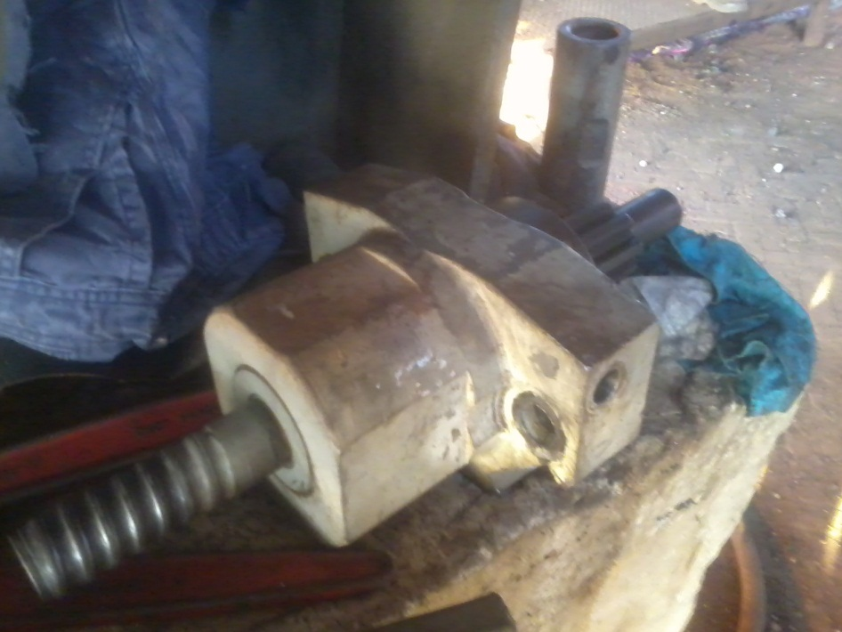

Remove both the bolts from here.

1. Now slide the entire assembly out as shown above.
2. Replace with the spare assembly & re tighten the bolts.
3. Ensure split pins are provided to lock nuts.
4. Connect the flushing hose back to its position.
5. Fix back the field key and release the emergency switchInform cast house operator to take trial of machine.
6. Clear work permit & hand over.

**Work No. 7** : **Removal of drill rod / shank adaptor incase of jamming.**

1. Take clearance from cast house in charge & operator.
2. Remove the field key located adjacent to the mudgun.
3. Using 2 pipe wrenches , loosen the drill rod & shank adaptors.
4. Fix back the field key and give clearance

**Work No. 8** : **Replacement of face plate .**

1. Take clearance from cast house in charge & operator.
2. Remove the field key located adjacent to the mudgun.
3. Remove the old face plate & replace with spare assembly
4. Fix back the field key and give clearance.

**Work No. 9: Lubrication of Drill machine**

1. Take clearance from cast house in charge & operator.
2. Remove the field key located adjacent to the mudgun.
3. Lubricate the machine as per pre identified points.
4. Fix back the field key and give clearnace.

* Work No 10 Drill machine assly replacement

1. Vertical shaft with foundation assembly replacement.

1. Take clearance from SS ,cast house in charge.

2. Remove the field key located adjacent to the drill machine.

3. Take electrical shutdown of Powerpack Pumps apply LOTO locks & take work permit.

4. Take the mechanical shutdown of the shut off valves of control strand in closed condition.

5. Remove the hoses drain oil in the barrel and put dummy .

6. Drill machine foundation to be cleaned for removing the foundation bolt nuts.

7. Feed beam with mounting assembly to be removed by help of chain block & crane Proper support to be given to feed beam.

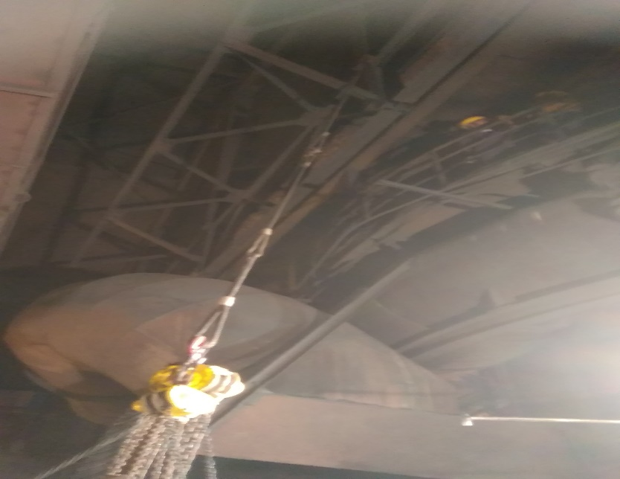

**CHAIN BLOCK SUPPORT GIVEN TO ASSEMBLY**

8. Then start loosing Drill machine foundation nut M50 (16 nos)

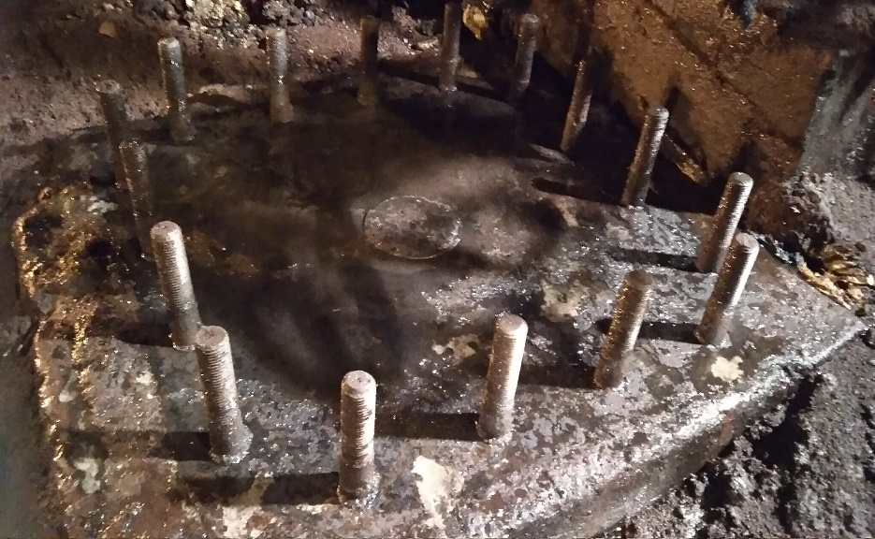

**DRILL MACHINE FOUNDATION NUT BOLTS**

9. Chain block (5T) and casthouse crane support should be given to rotating arm , base and main shaft. (rotating arm and main shft should be locked by welding with channel piece)

10. Start lifting the assembly slowly by chain block in upward direction, and after lifting at some height assembly should be pull at PCM side by help of crane alternately chain block should be lower at same time.

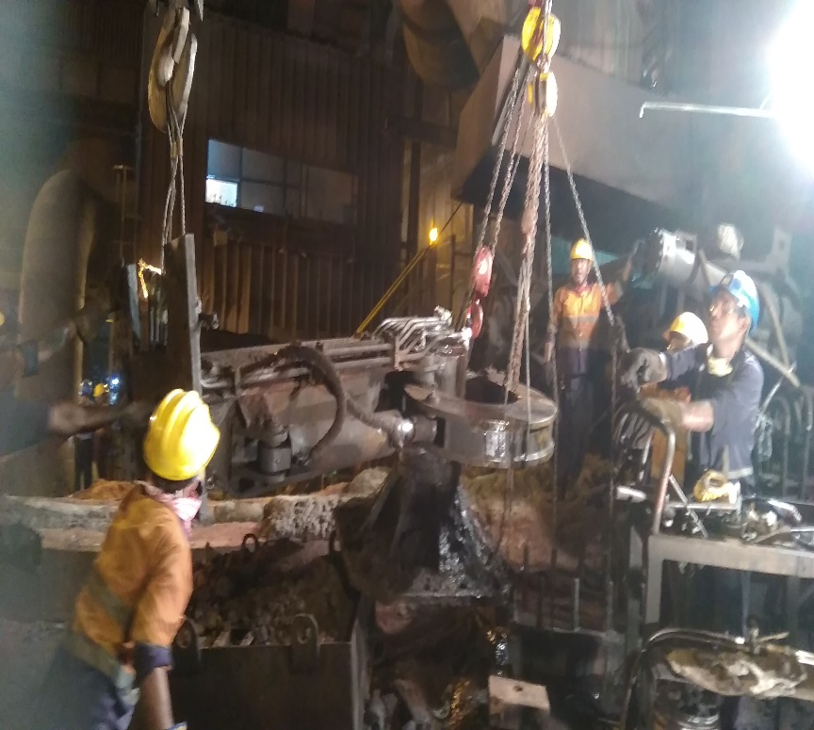

**LIFTING ASSEMBLY BY CHAIN BLOCK AND CASTHOUSE CRANE**

11. Hence assembly can be separated from its base bolt.

12. Before installing new assembly base area should be get clean by operation.

13. New assembly should be shifted to casthouse area before removing old assembly

14. New base and main shaft should be lifted by help of casthouse crane and alternately support should be given by chain block (5t) for pulling it towards base area.

15. After that crane should be lowered, alternately chain block should be lowered at same time.

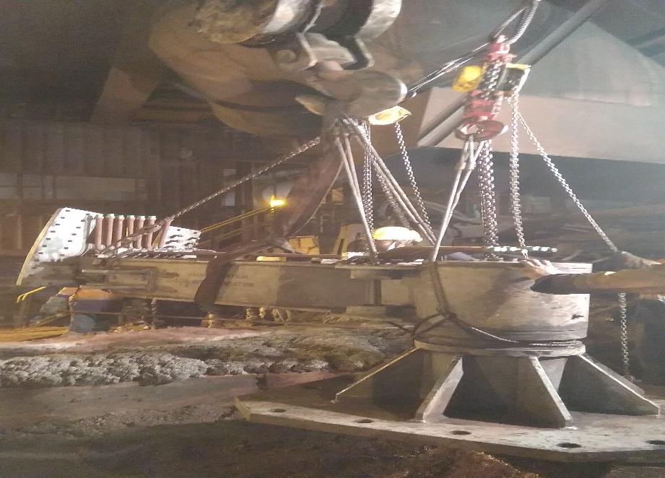

**LOWERING ASSEMBLY OF DRILL MACHINE**

16. After resting the base assembly to foundation bolts, tight all nuts M50(16 nos)

17. . Feed beam with mounting assembly to be installed by help of chain block & crane support to be given to feed beam.

18. Connect the hose pipes to assembly, replaced damaged hose with new.

19. . Open the shut off valves of control strand.

20. Clear electrical shutdown of pumps remove LOTO locks

21. . put the field key located adjacent to the drill machine.

22.Take trail of drill machine of rotation, drilling, hammering, forward, reverse by help of operator. (also check centering to taphole).

22.Clear the work permit.

23. Give clearance from cast house in charge.

# DO

* Take necessary precaution while working in cast house as it is a hot metal handling area
* Take necessary care while handling items, which are applied with grease and oil.
* Ensure nobody is the swing area of drill machine while taking trial.
* Use chain block wherever applicable as per procedure WI/MAINT/12.
* Place grating on the main runner in case you are working close to the runner.

### **DO NOT**

* Take trial of the machine by yourself. Only cast house operators and engineers are authorized to operate machine
* Cross over Hot metal launder.
* Move in close vicinity of the machine , without ensuring the machine is stopped & without removal of field key.

**Amendement Record**

|  |  |  |  |
| --- | --- | --- | --- |
| **Date** | **Manual Section Ref. & Para** | **Brief details of Revision** | **New Rev.** |
| 20/08/2023 | Work no: -6, Page 5 of 10 | It is decided to place protection plate while doing changing of shank shaft while cast is open. | Rev.05 |
|  |  |  |  |
|  |  |  |  |

|  |  |  |
| --- | --- | --- |
| **Prepared By:**  Digital head VAB | **Reviewed & Issued By:**  Management Representative | **Approved By:**  Mechanical and Asset Integrity Head VAB |
| **Signature:** | **Signature:** | **Signature:** |
| **Review Date: 15.08.2023** | **Review Date: 15.08.2023** | **Review Date: 15.08.2023** |